Concerts Con Brio

presents

Carl Gutowski and Friends
Musicians of ACMA

Music for Flute, Voice, and Piano

Music by Alfredo Casella, Claude Bolling, Gaetano Donizetti and more

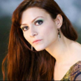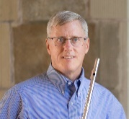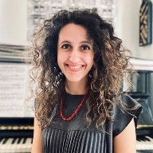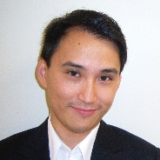

Sunday, September 28, 2024 at 4:00pm
Christ Church - 20 Carroll Street, Poughkeepsie

All are welcome!

Suggested donation: $25

