**Concerts Con Brio @ Christ Church**

presents

**Four Centuries of Music for Violin and Piano**

***Marka Young, Violin***

***James Fitzwilliam, Piano***

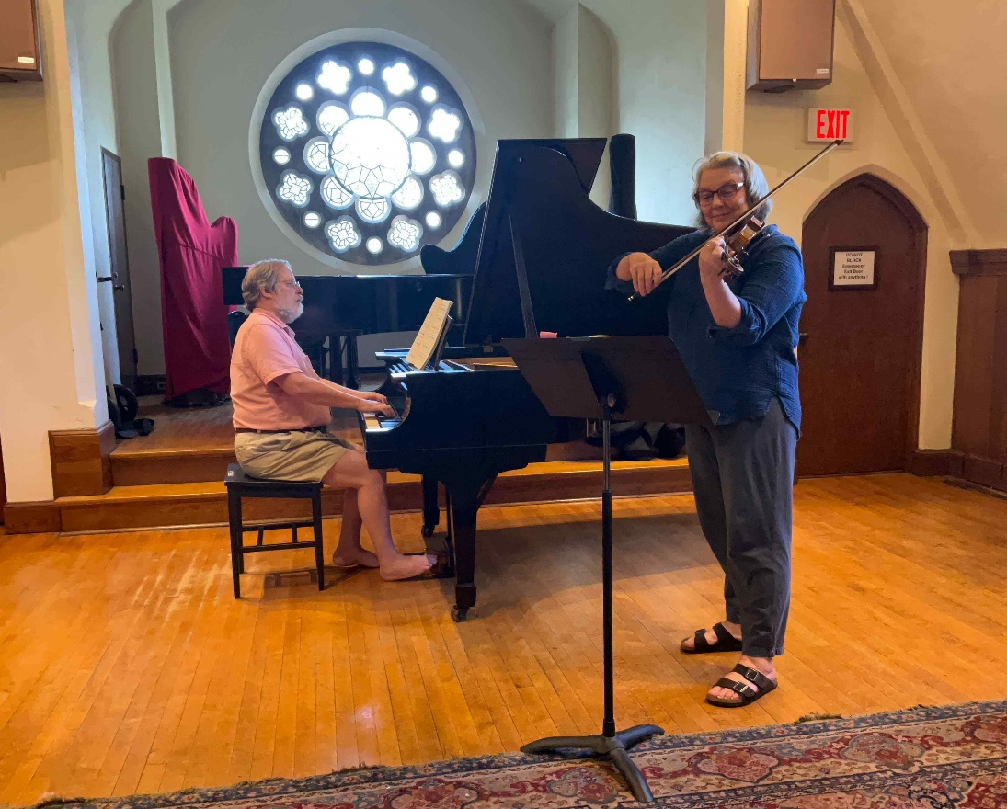

**Sunday, September 22, 2024 @ 4:00pm**

**Christ Church - 20 Carroll Street, Poughkeepsie**

**All are welcome!**

Suggested donation: $25